User Manual

Dundee & Angus College

Graded Unit Project HND Year 2

A Student

2017

Contents

Login 2

1.1 Login: 2

1.2 New User: 2

1.3 Adding New User: 3

Main Menu 3

2.1 Main Menu: 3

2.2 Add Player: 4

2.3 Remove Player: 4

2.4 Add Sponsor: 5

2.5 Remove Sponsor: 5

2.6 Edit Player: 6

2.7: Edit Sponsor: 6

2.8 Search Player By Name: 8

2.9 Search Sponsor By Name: 9

2.10 Profit And Loss Account: 9

Logout/Exit 10

3.1 Logout: 10

3.2 Exit: 10

FAQ 11

# Login

* 1. Login:

Enter your login details (User ID and Password) If you do not have a User ID or Password see 1.2

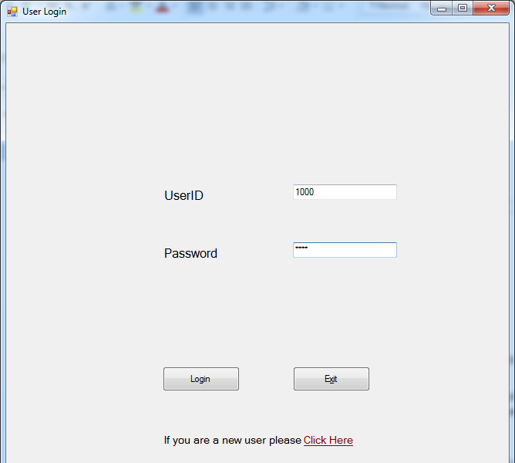

* 1. New User:

If you do not have login credentials click the new user link at the bottom of the login screen. Now get an existing member of staff to enter their credentials. If you are the first user the User ID is set to 1000, and the Password is set to test. This is merely a security measure to prevent anyone from adding a new user.

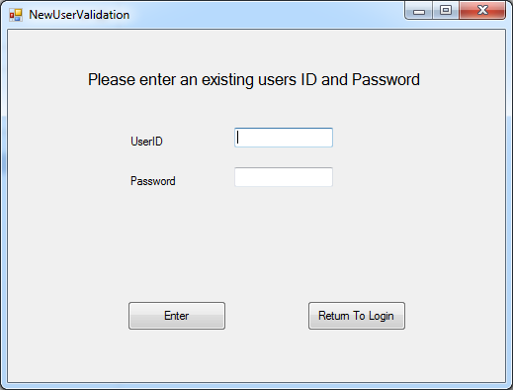

* 1. Adding New User:

Once the existing user has entered their credentials, you will be prompted with a User ID and Password box. You cannot insert a user ID, this will be given to you once you have entered your password and click the ‘Generate and Save’ button. Now click the ‘Return to Login’ button and login with your new details.

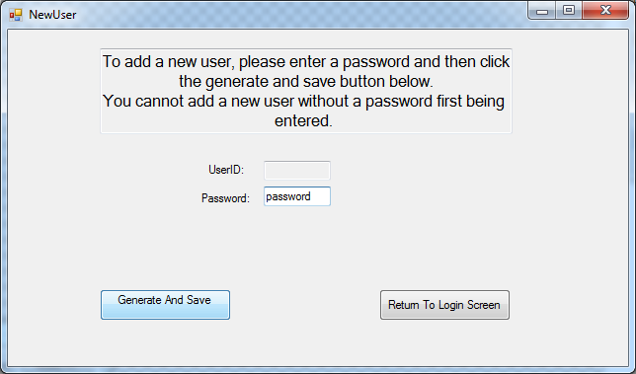

# Main Menu

2.1 Main Menu:

From here you can access every option in the program. Simply choose what you would like to do in the program e.g. add a player, add a sponsor etc.

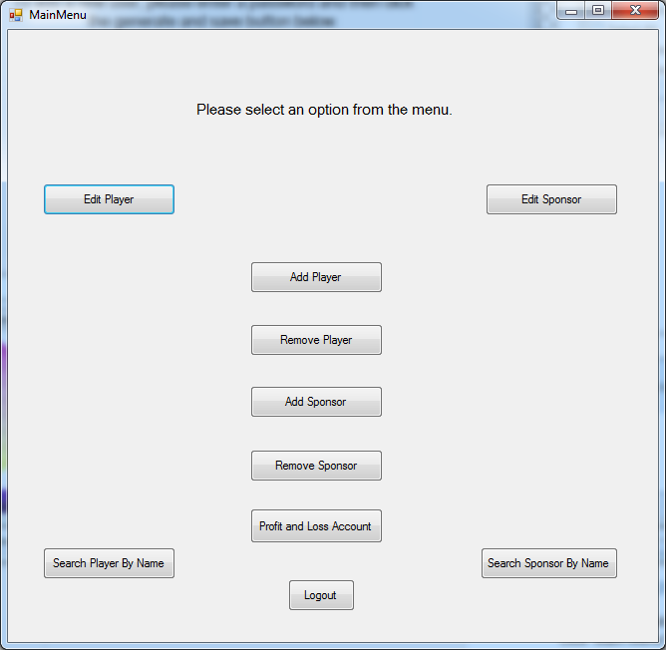

2.2 Add Player:

If you wish to add a player to the database fill in each field and click the ‘Gen and Save’ button. Click ‘Main Menu’ to return to the main menu.

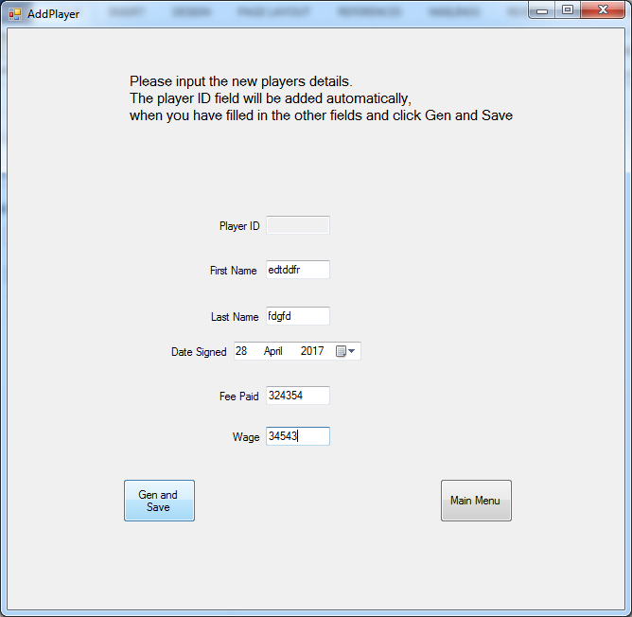

2.3 Remove Player:

If you wish to remove a current player select the desired player from the dropdown menu and click ‘delete’ Click ‘Main Menu’ to return to the main menu.

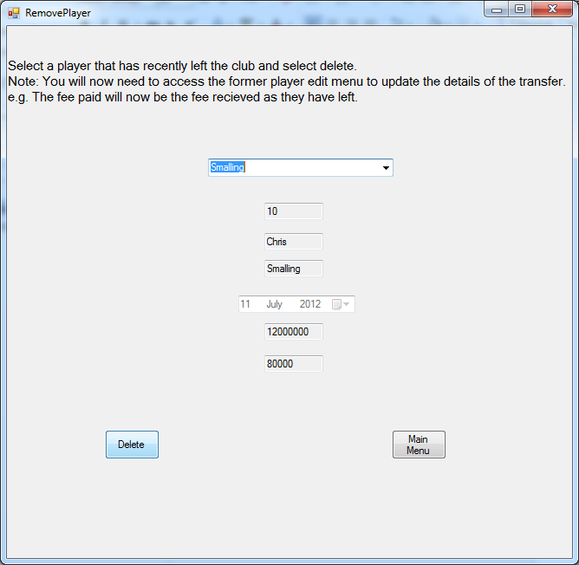

2.4 Add Sponsor:

If you wish to add a sponsor to the database fill in each field and click the ‘Gen and Save’ button. Click ‘Main Menu’ to return to the main menu.

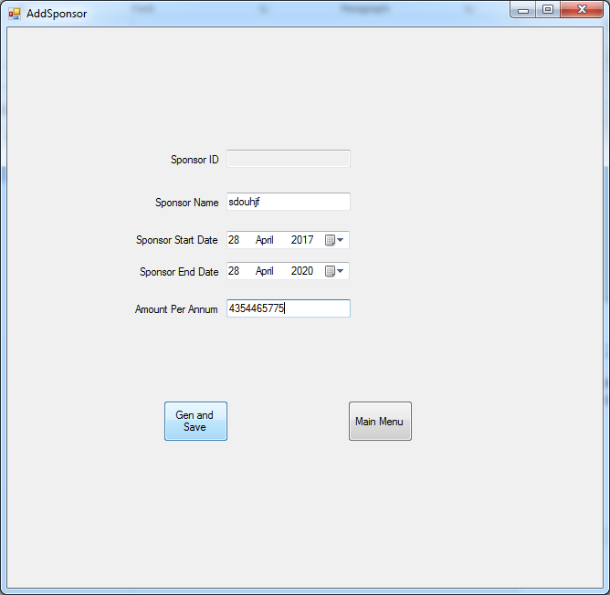

2.5 Remove Sponsor:

If you wish to remove a sponsor select the desired sponsor from the dropdown menu and click ‘delete’ Click ‘Main Menu’ to return to the main menu.

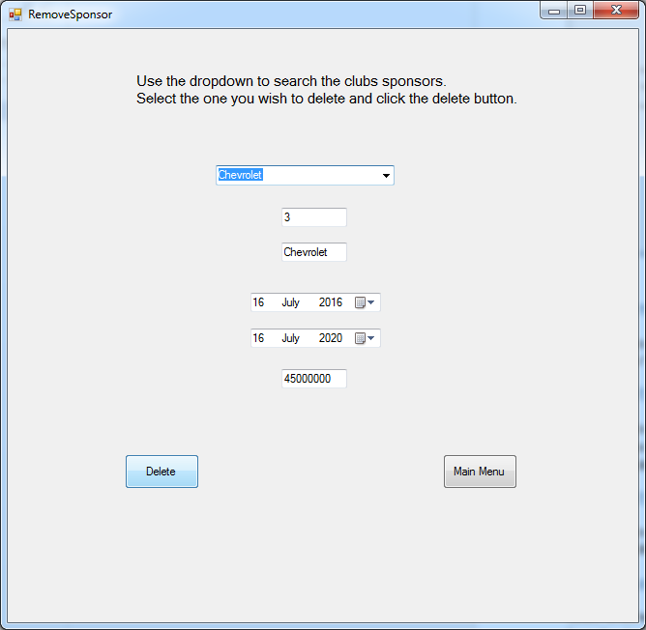

2.6 Edit Player:

If you wish to edit a player you must select whether they are a current player or a former player. Once this has been selected choose a player from the dropdown and edit their details (Player ID cannot be edited) and then click ’Update’. Click ‘Main Menu’ to return to the main menu.

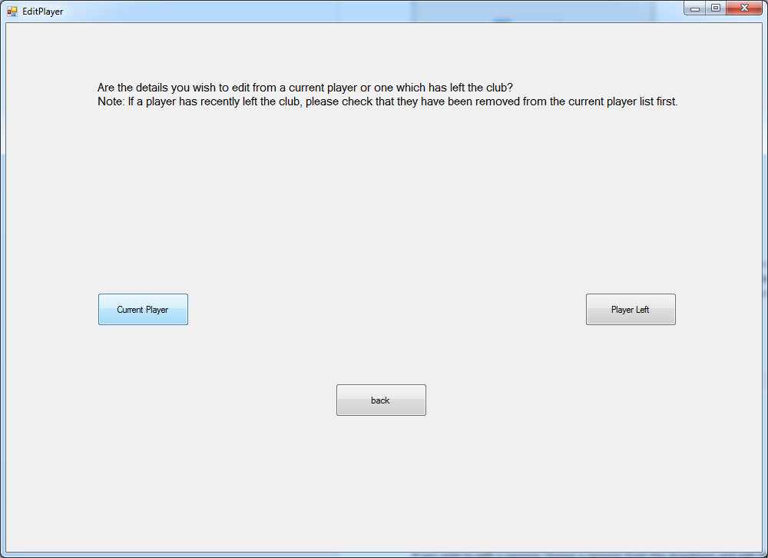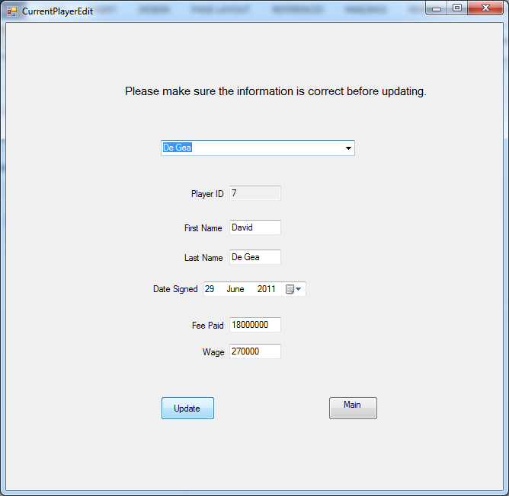

2.7: Edit Sponsor:

If you wish to edit a sponsor choose a sponsor from the dropdown and edit their details (Sponsor ID cannot be edited) and then click ’Update’. Click ‘Main Menu’ to return to the main menu.

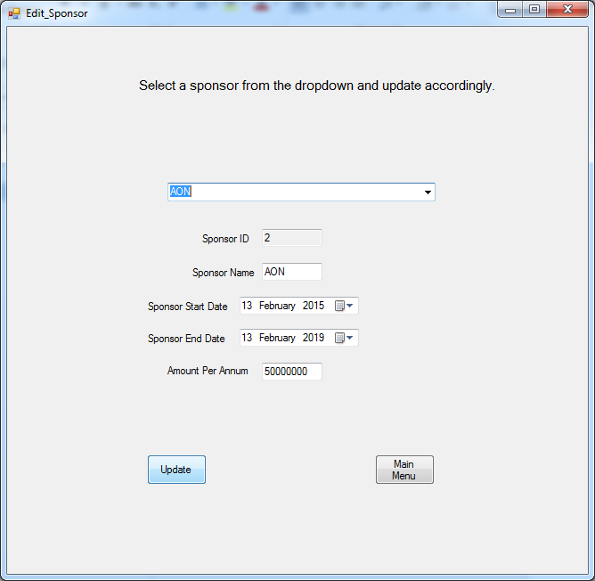

2.8 Search Player By Name:

Select whether the player you wish to search for is a current or former player. Then select a player from the dropdown to see their details in the window below. You can select as many players as you wish. The clear contents button will clear the searches from the window. Click main menu to return to the main menu.

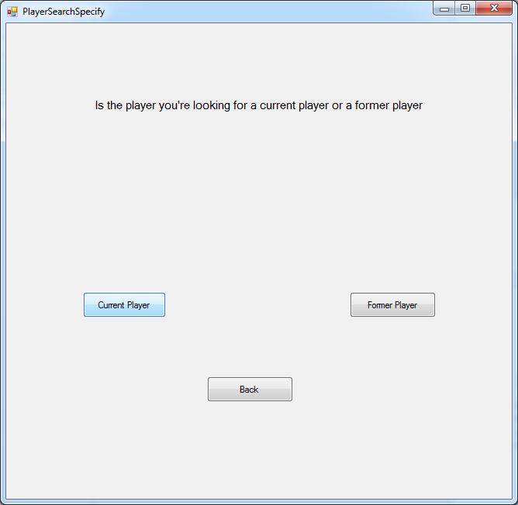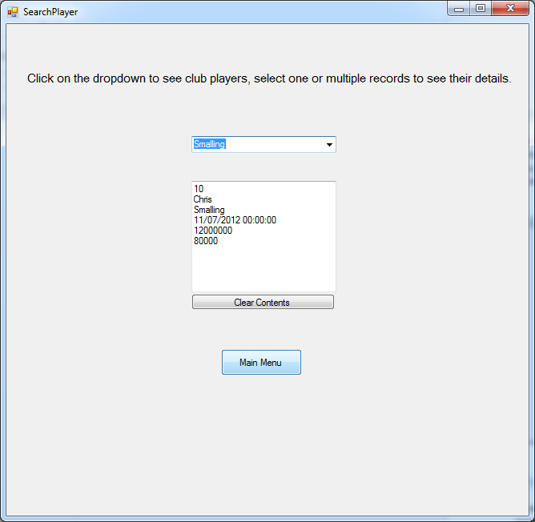

2.9 Search Sponsor By Name:

Select a sponsor from the dropdown to see their details in the window below. You can select as many sponsors as you wish. The clear contents button will clear the searches from the window. Click main menu to return to the main menu.

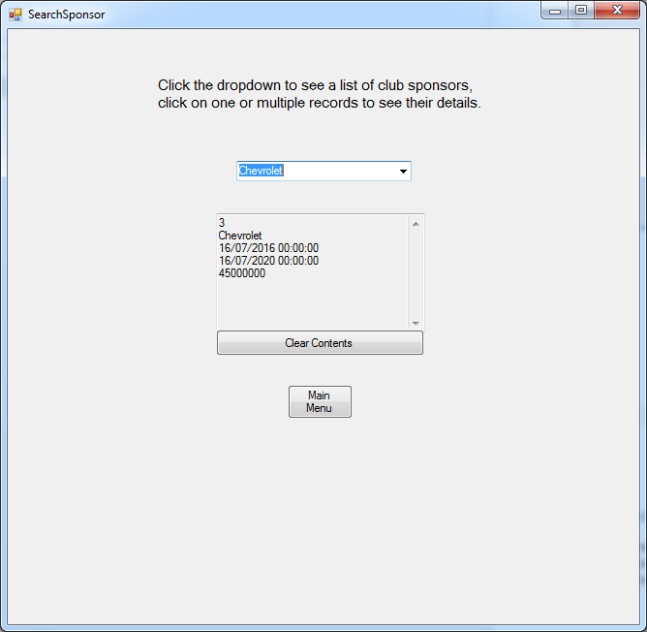

2.10 Profit And Loss Account:

This shows various totals from the database. The only way these will change is by adding, deleting, or editing a player or sponsors details.

Total Fees Paid: Shows the total amount spent on the current players in the database.

Total Wages Paid: Shows the total amount of wages spent by the club to pay the current players.

Total Sales Made: Shows the total amount of money made from selling players.

Total Wages Recouped: Shows the total amount of wages saved from the players they have sold.

Total Received By Sponsors Per Year: Shows the total amount of money made from sponsors per year.

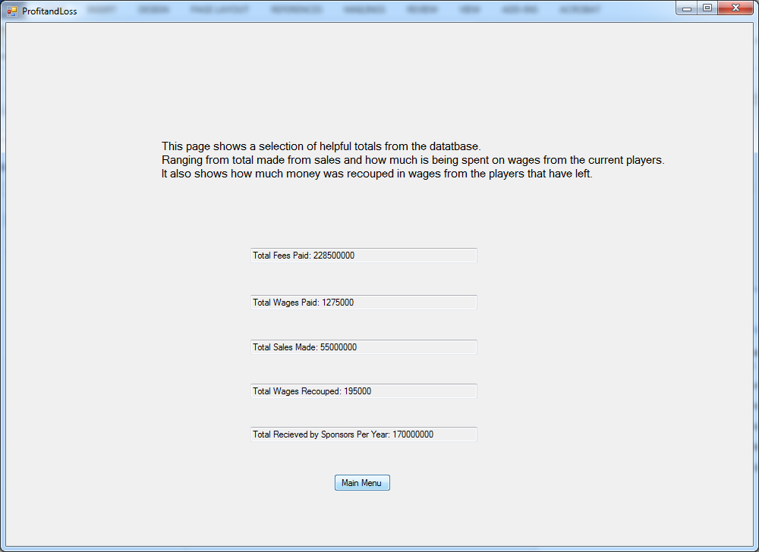

# Logout/Exit

3.1 Logout:

This will take you back to the login screen. To access the main menu again you will have to input your User ID and Password again.

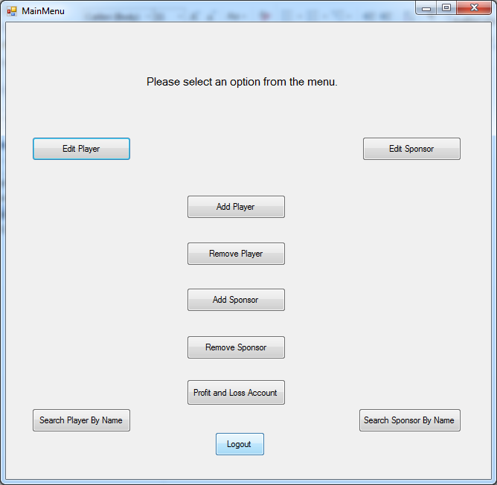

3.2 Exit:

This will close the program.

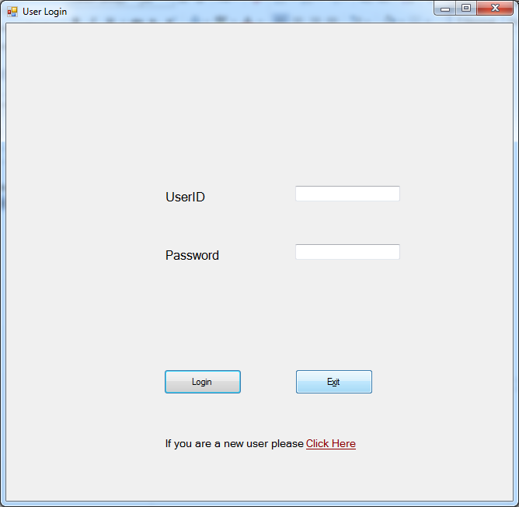

# FAQ

Why Can’t I log in?

This will be because you are either entering the wrong User ID or Password. Incidentally you may not have a User ID or Password.

What if I’ve entered a player’s details wrong?

Simply click the edit player button, select whether they are a former player or current player, then select their name from the dropdown, amend the details, click update and then click main menu.

What if I’ve forgotten my User ID and/or Password?

Bad News. You will not be able to access these again, you were told to keep a note of these and warned you wouldn’t be able to change them. You will have to request a new user ID and password from another current employee.